FARM2FARM E_COMMERCE DATABASE

1.Database Design:
1.1Seller Table:
Attribute Data Type Constraint
SELLER_ID NUMBER(5) PRIMARY KEY
SELLER_NAME VARCHAR2(100) NOT NULL
EMAIL VARCHAR2(100) NOT NULL, UNIQUE
CONTACT_NO VARCHAR2(15) NOT NULL, UNIQUE
ADDRESS VARCHAR2(200) NOT NULL
1.2Inventory Table:
Attribute Data Type constraints
INVENTORY_ID NUMBER(5) PRIMARY KEY
SELLER_ID NUMBER(5) FOREIGN KEY
PRODUCT_ID NUMBER(5) FOREIGN KEY
STOCK_QUANTITY NUMBER(5) NOT NULL, CHECK
PRODUCT_STATUS VARCHAR2(20) NOT NULL
LAST_UPDATED DATE NOT NULL
2.Table Relationships:
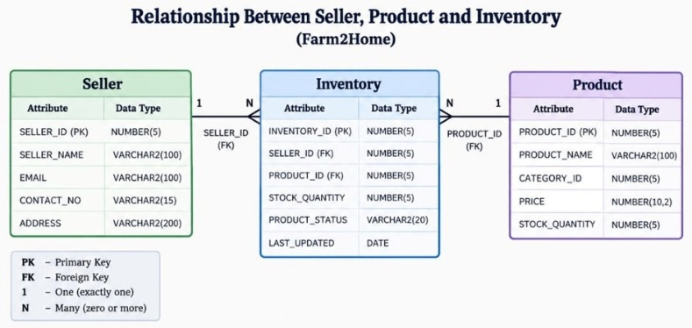
3.Table Creation:
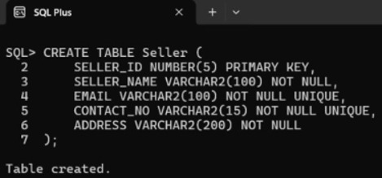
3.1 Create Seller Table:

3.2 Create Inventory Table:
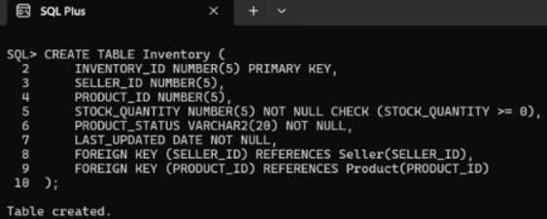

4.Seller Data Insertion:
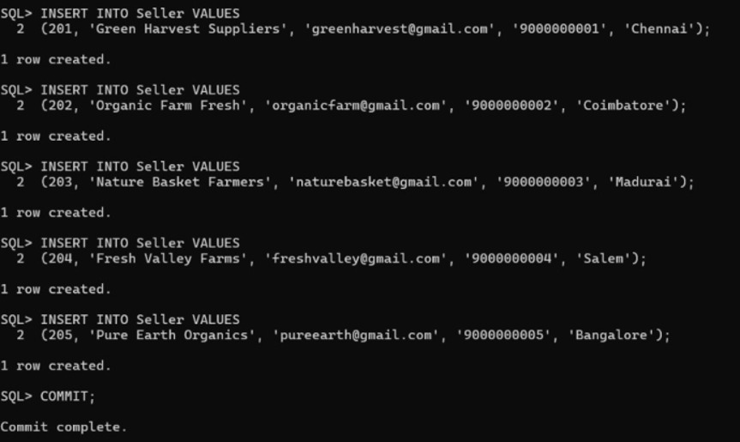

5.Inventory Data Insertion:
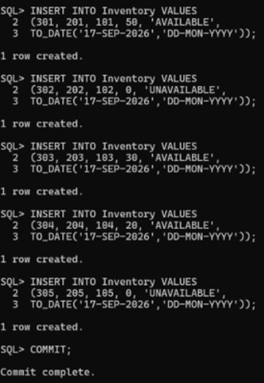

6.Seller Product Information:

6.1 Display Seller And Product Details:
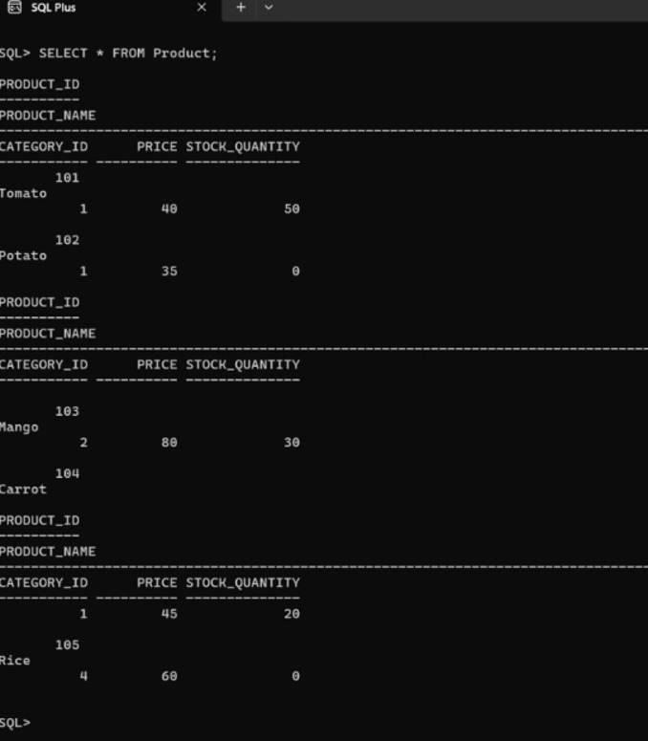

7.Inventory Status:
7.1 Display Available Products:

7.2Display Unavailable Products:
8.Inventory Update:

